

A Project Report On

**SCHOOL MANAGEMENT**

**SYSTEM PROJECT**

**By**

**Batch:** 2022 – 7671

**Center: Chennai chrompet**

Under the Guidance of,

**Chittaranjan Ghosh.**

**Technical Trainer**

**EduBridge**

(School of coding)

**Introduction:**

This project explains about the School management system. It is

project based on various LogIn available in school management system. We can

LogIn with various LogIn with corresponding mail and password, with that we can view details, we can add new student, can view student details, we can manage student fees like pay fees. Our Project Include

.

**Modules:-**

* Admin Module
* Faculty Module
* Accountant Module
* Student Module

|  |
| --- |
|  |

I have developed this Application in **Java and MySQL.** It’s a console-based project.

The main feature of the project is to make manage school records easier.

In **Admin module**, admin can view the entire school records, he can add new student to class, he can view student details, accountant details, faculty details. He can make new admission, this option also available in admin login.

In **Faculty module**, faculty can view their personal details, they can view student details, student marksheet- marks scored in exams.

In **Accountant module**, accountant can view student fees details like total fees, fees paid, fees pending also he can make changes in the fees structure of student, student can pay their fees by accountant.

In **Student module**, student can view their personal details, they can view their marksheet - marks scored in exams.

**Software Requirements:**

**Software :** Eclipse, MySQL

**Operating System:** Window 11.

**Data Dictionary:**

**Table creation:**

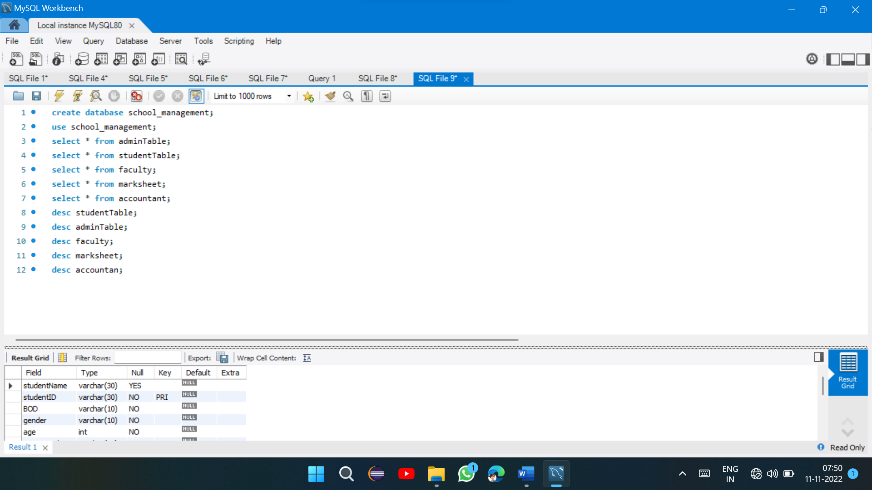

**Log In options:**

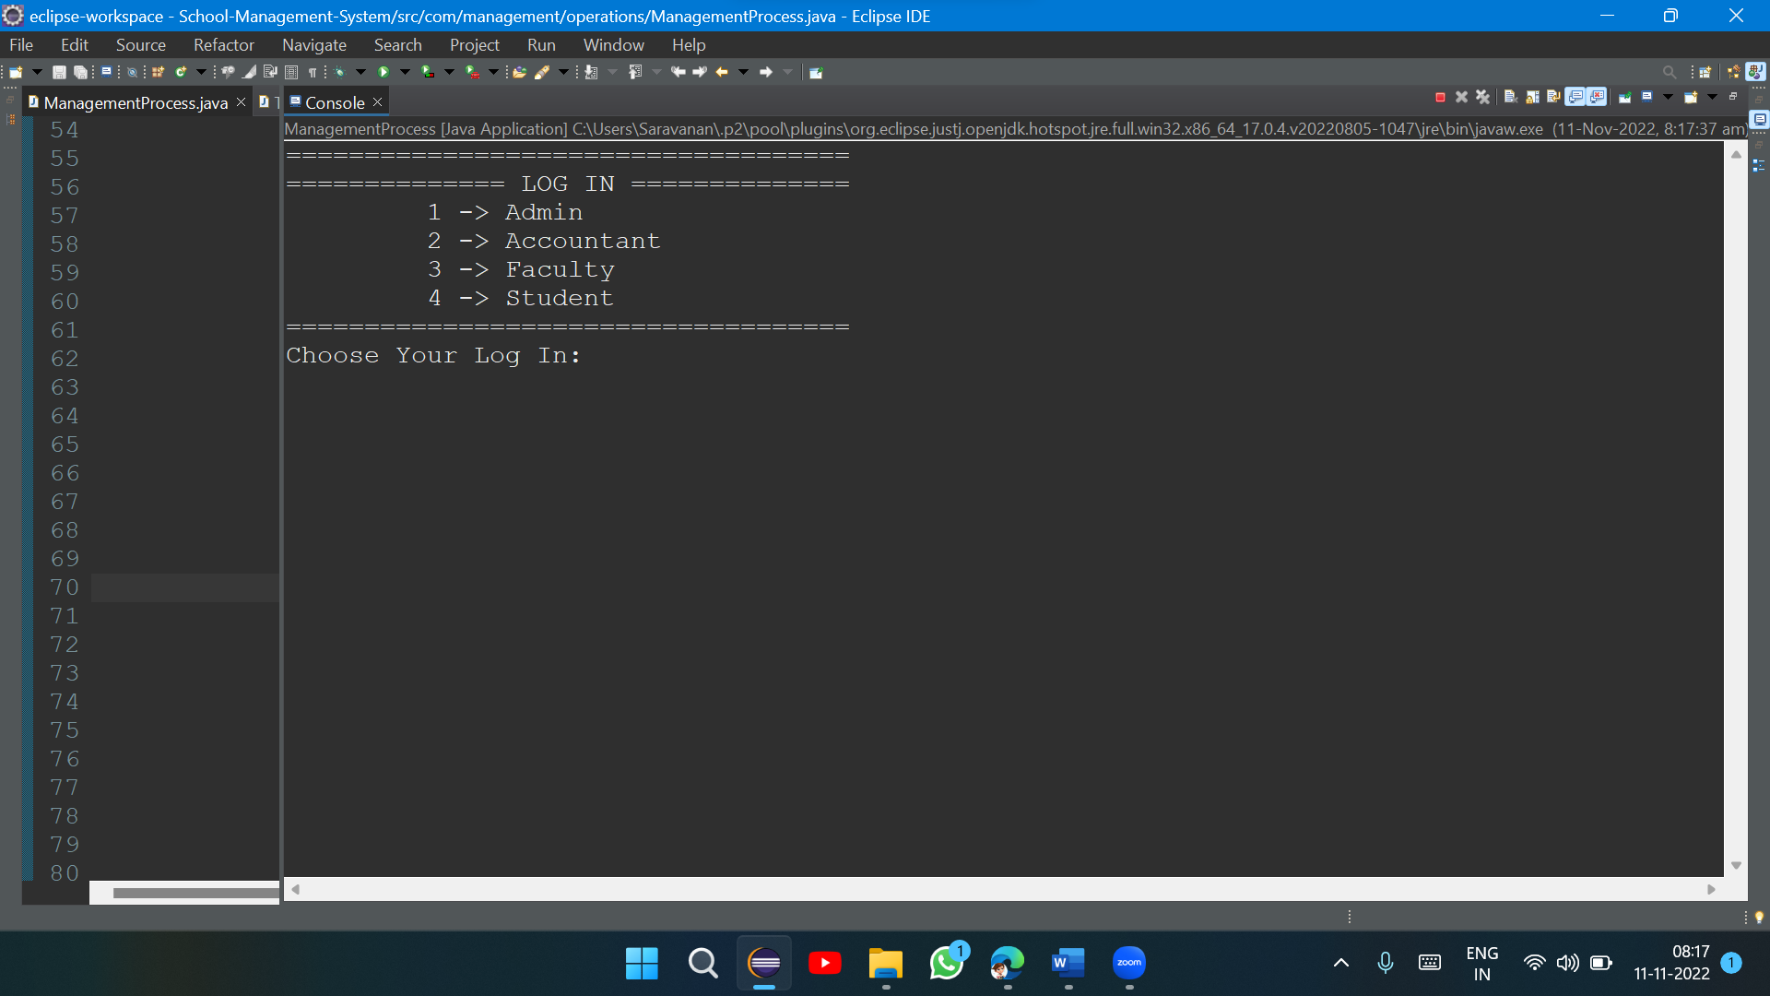

Here, we can use different log in for the school management.

**Admin Log In:**

Admin can have four options

* To view Accountant details
* To view student details
* To view faculty details
* Log out

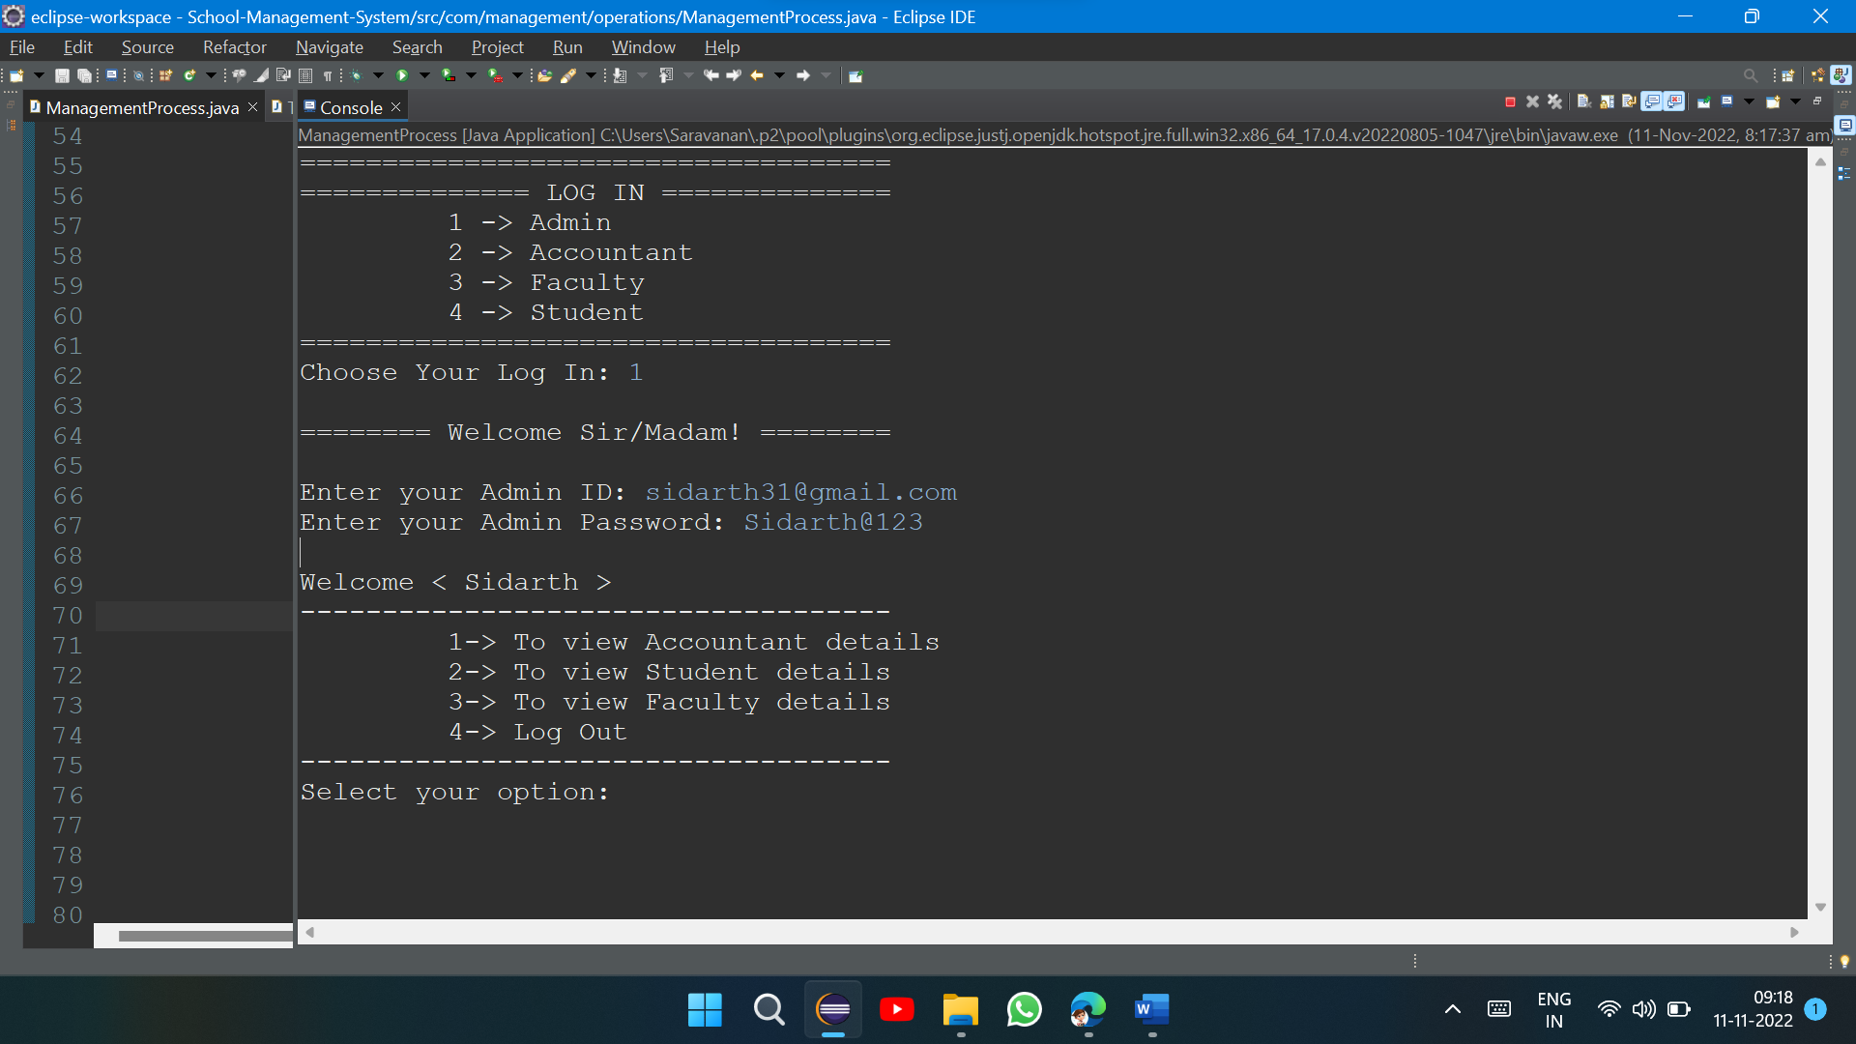

1. view Accountant details
   * In accountant, admin can view accountant profile, and go back, log out options also available, he can use those options, it is user friendly options
2. view Student details
   * In Student, admin can make new student admission, view student profile and also go back and log out options also available, he can use those options, it is user friendly options
3. View faculty details
   * In accountant option, admin can view the faculty profile. Log out and go back options available, if admin feel, to select other options in main menu he/she can go back to main menu and choose options he/she want. Log out option will log out from the current log in.
4. Log out
   * This option will log out from the current log in.

**Accountant log in:**

Accountant have the following options

* View student fees structure
* Manage student fees structure
* Log out

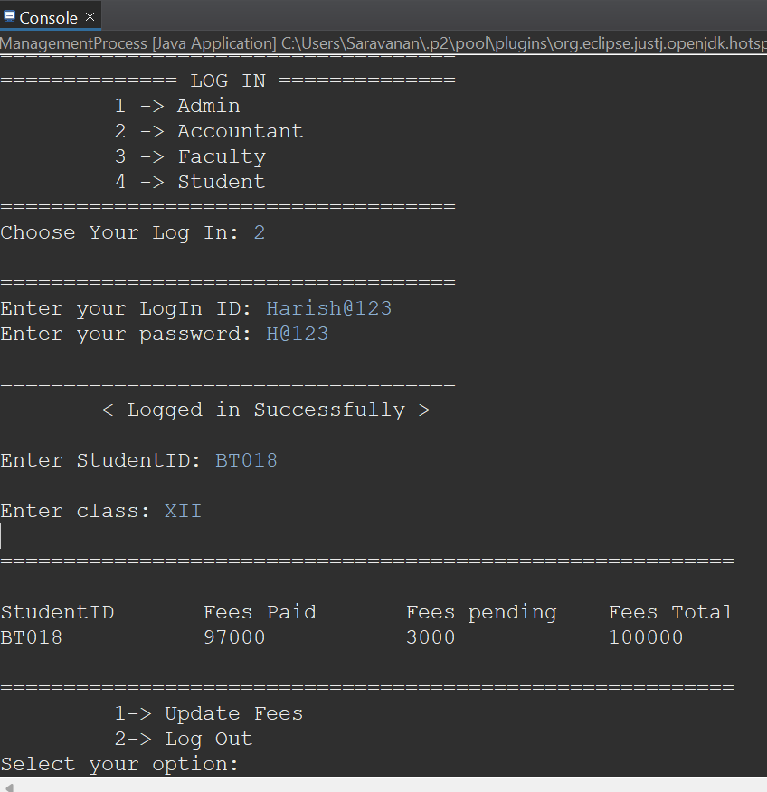

**Faculty log in:**

Faculty have the following options

* View profile
* View student marksheet
* Log out

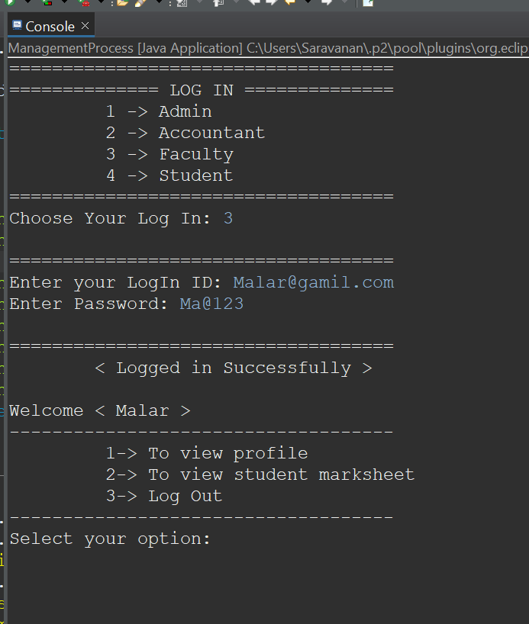

**Student log in:**

Student log in having the following options

* View profile
* View marksheet
* Log out

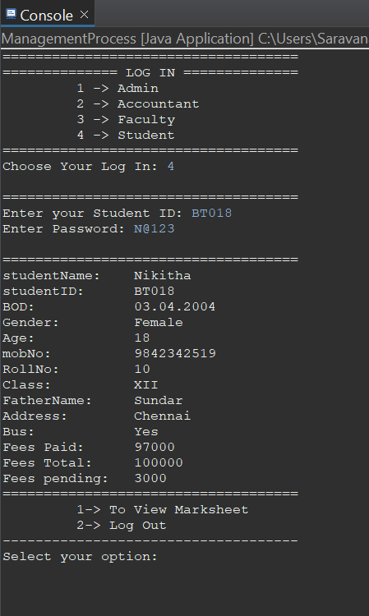

**Conclusion:**

This is my mini project, running process of console based mini-project is displaced in this documentation.

**Thank You**